Manduessedum - Mancetter Village (Place of War Chariots)
Mancetter Parish Council
Serving the People of Mancetter and Ridge Lane

You are invited to an Extraordinary Parish Council Meeting
to be held in the Schoolroom of St Peter’s Church Mancetter
on Tuesday 25th June 2024 at 7pm.

AGENDA

- Welcome and Apologies.
- Chairman’s request that anyone recording the meeting make themselves known, to allow
openness and recognise practicalities.

- Declared Notice of Interest by Councillors concerning Agenda items.
- Public Question time of up to 15 Minutes for Parishioners to raise issues.
- Formal receipt of the accounts for 2023/2024.
- Formal signing of section one of the Annual Governance and Accountability Return for
the year 2023/24 – Annual Governance Statement.
- Formal signing of section two of the Annual Governance and Accountability Return for
the year 2023/24 – Accounting Statements.
- To confirm the dates for the Notice of Public Rights and Publication of unaudited Annual
Governance and Accountability Return for year ended 31st March 2024.

- To examine and approve the updated financial regulations based upon the 2024 JPAG guidance and the new NALC Model financial regulations issued in April 2024.

- To examine the current asset register and allocation of reserves and authorise any amendments.

- Date of next meeting- Tuesday 23rd July 2024 7PM AT ST PETERS CHURCH SCHOOLROOM

Signed: 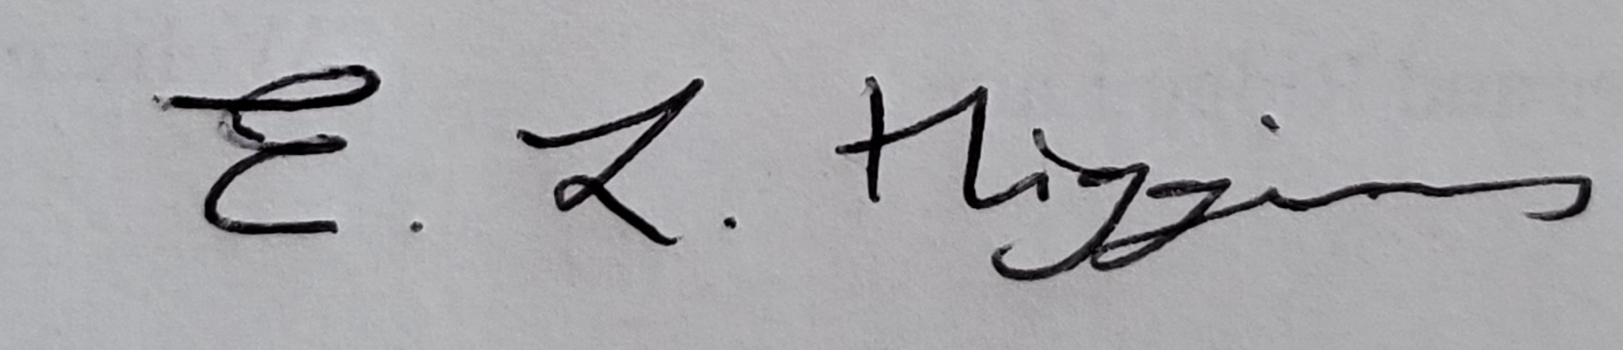

Date: 19th June 2024.

Elane Higgins
Parish Clerk Mancetter Memorial Hall Old Farm Road Mancetter CV9 1QN Tel: 01827 722552 / 07368 265051
Email: parishclerk@mancetter.gov.uk
Website: www.mancetter.gov.uk

